Analysis Report Template

Student Full Name | Methira Binath Kahawita | Student ID No. | 20240021
Case Study Title
Case Study (A): Predicting Clients Loan Status. [Total 43 Marks]
Research Question: Does machine learning have the potential to assist banker and finance analysts in predicting which client can be approved a loan?

Task (1) – Domain Understanding: Classification
The financial risk analysts decided that classification modelling is required. Indicate in the table below for each of the listed
variables in your data which ones you should RETAIN and can be included in the classification modelling of loan approval status, and the variables you should DROP (REMOVE). Justify your decision logically and/or by research (for any research, include in-text citation using
the Harvard style) [3 Marks]
Variable Name | RETAIN or DROP | Brief justification for retention or dropping with in-text citation.
ID | DROP | This -does not contribute to the fact of predicting loan approval because it d  does not contain any meaningful value
Sex | RETAIN | Some times this may influence financial behaviour an when approving the decisions regarding the loan approval because of the financial independency and pay gap
Age | RETAIN | Age is main factor that reflects financial stability and repayment ability ,  which can impact the decision of the loan approval
Education Qualifications | RETAIN | Education level can indicate the persons earning potential and  financial reliability.
Income | RETAIN | This is One of the most important factors as the income directly affects  repayment capability because the person should pay the loan with  the income he receives
Home Ownership | RETAIN | This Indicates the financial stability and asset ownership,  influencing creditworthiness that this person can afford valuable assets .and use these in case of emergency to pay the loan
Employment Length | RETAIN | If the persons career has a Longer employment it suggests  stable income and lower percentage of risk.
Loan Intent | RETAIN | This Helps assess or else calculate the risk depending on the purpose of the request of  the loan like medical vs personal spending.
Loan Amount | RETAIN | Higher loan amounts means increase of the risk that the person wont  be able to repay and this will affect approval decisions
Loan Interest Rate | RETAIN | This factor Reflects the borrowing risk like higher rates often indicate  that the requesting applicant is higher-risk  applicants
Loan-to-Income Ratio (LTI) | RETAIN | Key financial metric used by lenders to assess affordability
Payment Default on File | RETAIN | This one Strong predictor of future default behaviour
Credit History Length | RETAIN | If the applicant has longer history of credit history it provides more reliable assessment of credit behaviour
Loan Approval Status | RETAIN | This is the target variable for classification this is required  to train the model.
Maximum Loan Amount | DROP | This Causes data leakage as it is determined after the approval of the loan ;  not available at prediction time
Credit Application Acceptance | DROP | Duplicate / related to target variable, leading to redundancy and  potential leakage.
References
Crook, J., Edelman, D. and Thomas, L. (2007). Recent developments in consumer credit risk assessment. European Journal of Operational Research, 183(3), pp.1447–1465.

Han, J., Kamber, M. and Pei, J. (2011). Data Mining: Concepts and Techniques. 3rd ed. Morgan Kaufmann.

Kuhn, M. and Johnson, K. (2013). Applied Predictive Modeling. New York: Springer.

Lessmann, S., Baesens, B., Seow, H.V. and Thomas, L.C. (2015). Benchmarking state-of-the-art classification algorithms for credit scoring. European Journal of Operational Research, 247(1), pp.124–136.

Task (2) – Exploring and Understanding Your Dataset

- Basic Descriptive Statistics

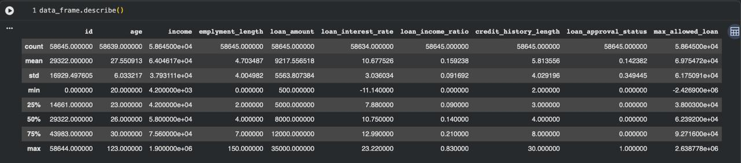

summary statistics such as mean, standard deviation, minimum, and maximum values for the numerical variables in the dataset.

- Variable Scale Types

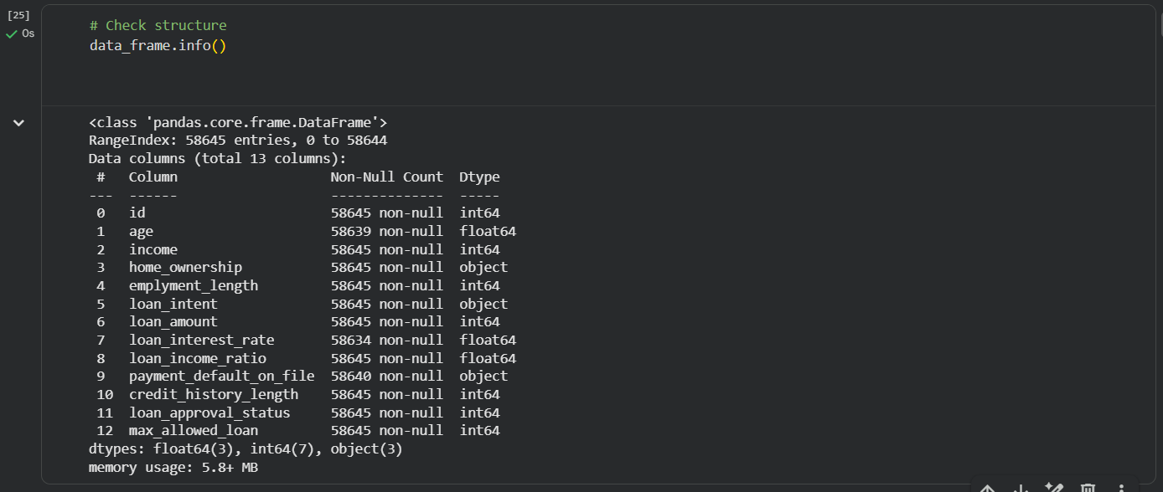

- Target Variable Distribution

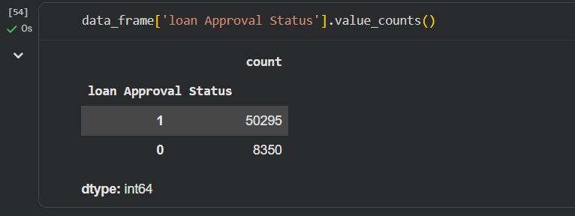

This screenshot shows the number of approved and not approved loans, this helping to understand the class distribution and whether the given dataset is balanced

The graph:

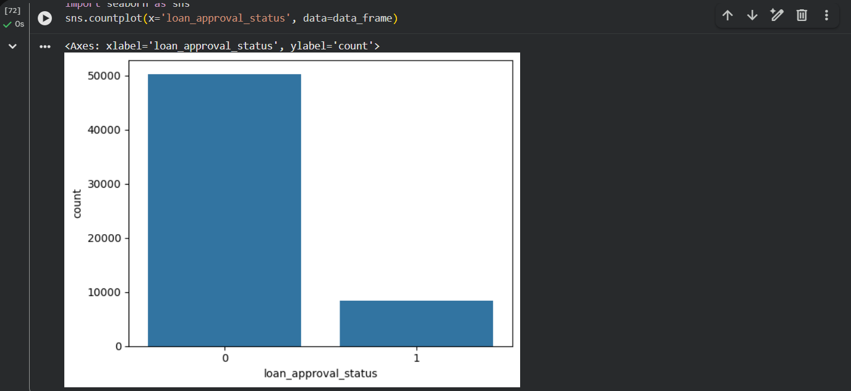

This shows the distribution of the loan approval status

Task (3) – Data Preparation: Cleaning and Transforming your data
a) With the aid of your Final Python Notebook 1, when you first explored your retained variables in the loan dataset, you may have found some issues. 1) Report any issues you found in your retained dataset variables. Based on the issues you found in your data, 2)suggest a suitable possible method to fix each of these issues and 3)provide your justification for using your suggested fix method. Use the table below to organise your findings and analysis, and add more rows if needed
[4 Marks]
 | Variable Name | Issue found | Proposed fix | Justification for used fix method
1 | employment_length | Column name was incorrectly written as(employment_length | Renamed the column correctly | Ensures the consistency and avoids errors during processing and modelling many operations can go wrong
2 | age, max_allowed_loan, loan_interest_rate, employment_length | Presence of outliers | Detected this using IQR method | Helps identify extreme values that may distort model performance
3 | max_allowed_loan, loan_interest_rate | Negative values -invalid | Removed those invalid rows | Negative values are unrealistic in financial context specially in these 2 categories
4 | employment_length | Values greater than 40 years | Removed these unrealistic values | If a person starts working at 20 yrs old maximum employment age is 60 yrs so values much larger than 40 should be removed
5 | age | Unrealistic values (>100) | Filtered dataset | It is rare that a person can live up to more than 100 years and a person if lives up there cant be a guarantee that he would stay alive to repay the loan.
6 | Categorical variables | They were in Text format (non-numeric) | Applied Label Encoding | A Machine learning models always require numerical inputs otherwise it might tamper with the outputs received by the model
7 | loan_approval_status | Values flipped (incorrect encoding) | Reversing the values (0→1, 1→0) | Because here non approved loans cant have maximum loan amount and sometimes approved loans have minus maximum loan amount so the values should be flipped
8 | Numerical variables | Missing values | Filled the spaces using median | Median is a method of single imputation that use to robust to outliers and maintains the distribution

Task (3) – Data Preparation: Cleaning and Transforming your data

b) With the aid of Python packages and your Final Python Notebook 1, implement your suggested fixes of issues in the previous Task 3-a in your final Python Notebook1.
1) Show evidence (before and after) of implementing your suggested fix to the problems you identified for your dataset in Task 3-a.
To show your evidence, paste screenshots of your relevant code OUTPUTS ONLY (Do not paste the code).
2) Indicate and annotate the issue and the fix in each of your provided evidence screenshots.
[4 Marks]
Output screenshot of the issue before the fix | Output screenshot after fixing the issue

- ISSUE 1 – invalid name emplyment_length

BEFORE

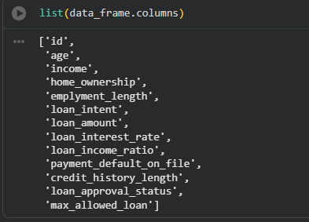
The column name was incorrectly written as emplyment_length, which will may cause errors in further going down making the model because when we try to call that variable we will use the real name with correct spelling always so this will be a issue .

After Fix (Solution)

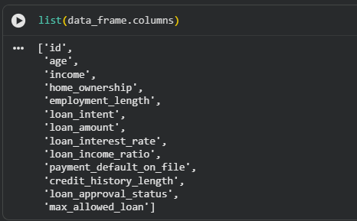

- Issue 2: Missing Values

Before Fix

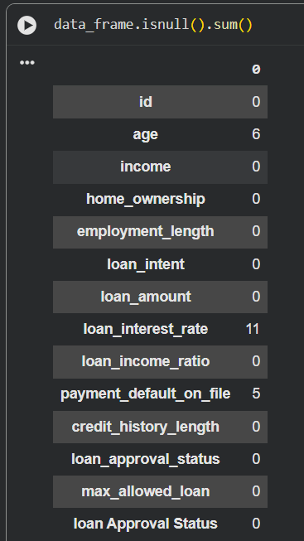

Number of missing values per column was identified before

After Fix

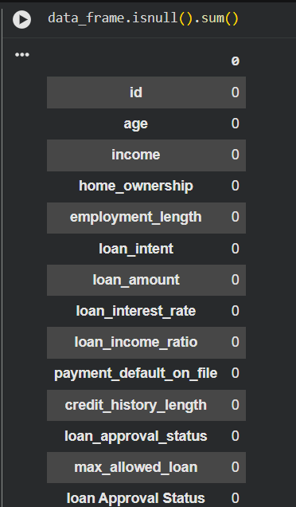

- Issue 3: Negative Values

Before Fix

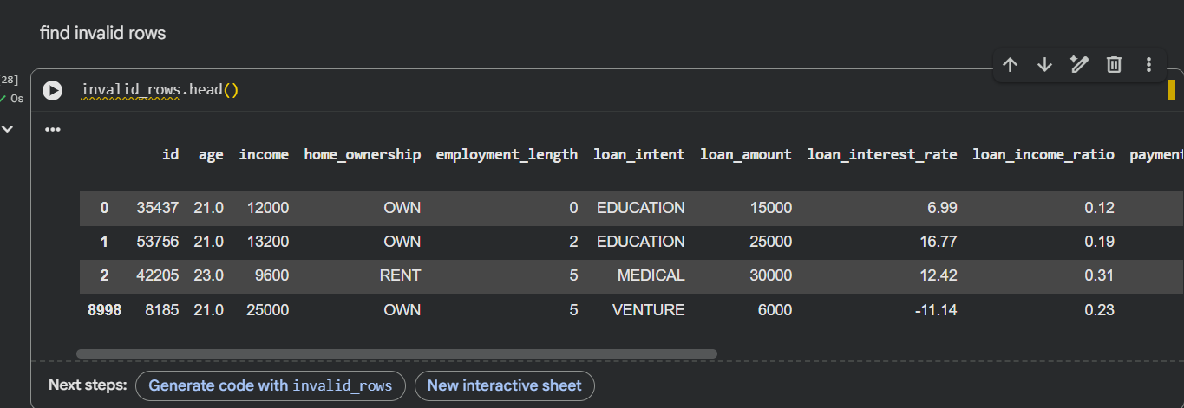

Number of Negative values were found in max_allowed_loan and loan_interest_rate, which are unrealistic range because max allowed loan and loan interest rate cant be minus .

After fix

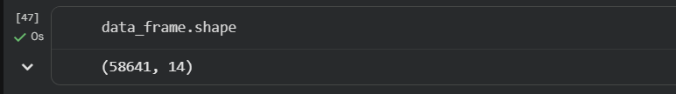

All the Rows with negative values were removed, this helps to improving data validity .

- Issue 4: Outliers

Before Fix

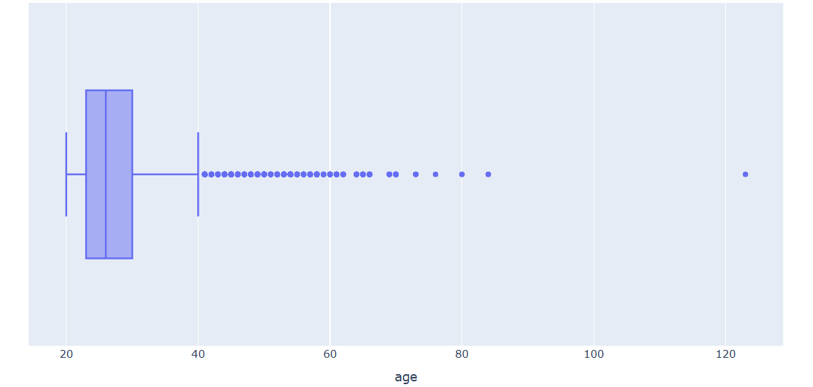

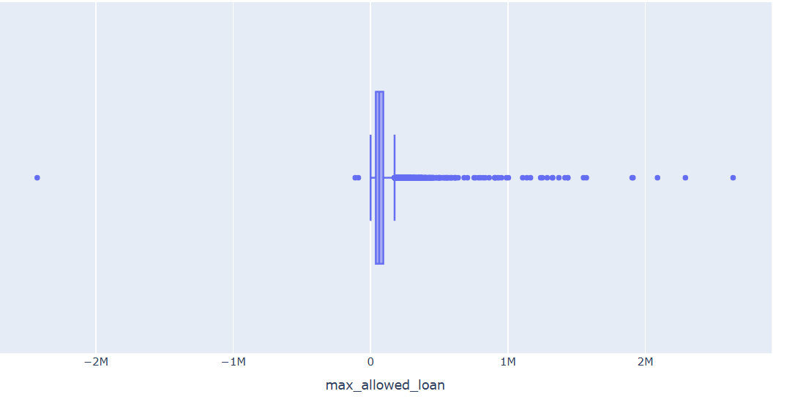
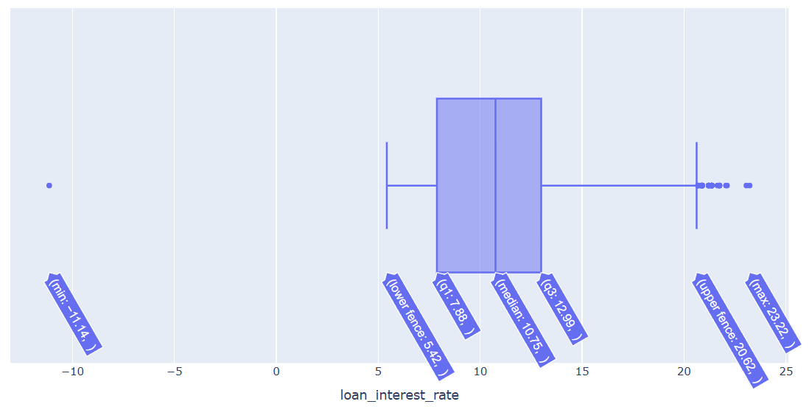

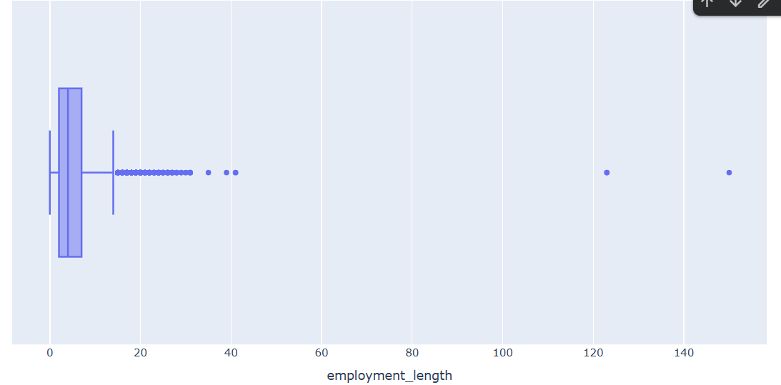

After Fix

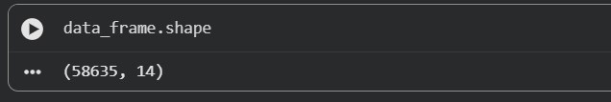

After removing all the outliers, the dataset size got reduced, this indicating that extreme and unrealistic outlier values were successfully removed.

- Issue 5: Unrealistic Employment Length

Before Fix

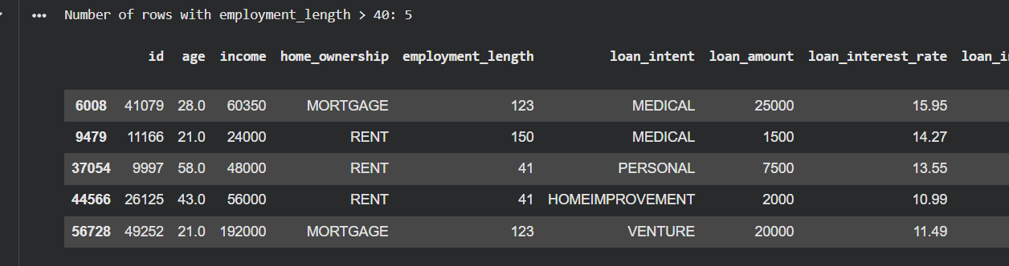

Here Employment length values greater than 40 years were identified as unrealistic.

After Fix

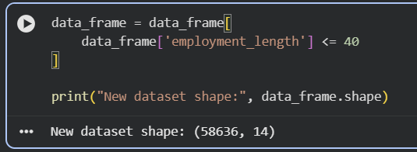

Unrealistic employment length values were removed to ensure that the data reflects real world conditions .

- Issue 6: Unrealistic Age

Before Fix

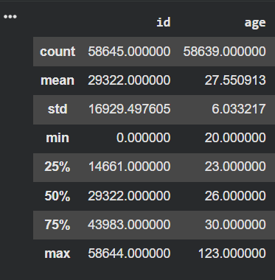

After Fix

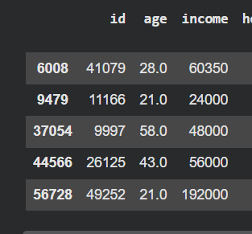

The Ages above 100 were removed to maintain realistic data.

- Issue 7: Categorical Encoding

Before Fix

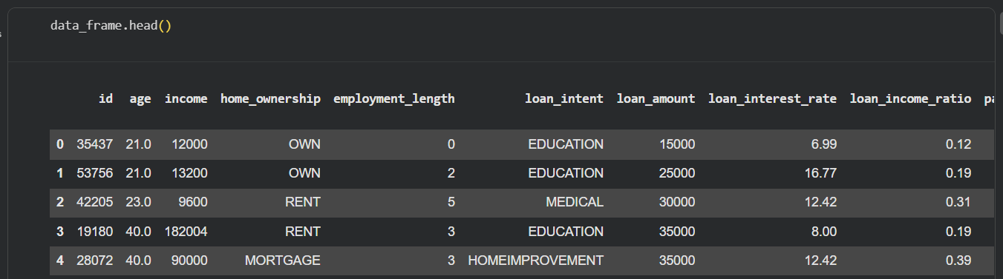

Here number of Categorical variables were in the text format, these cannot be processed by machine
learning model so need to be converted to numerical format .

After Fix

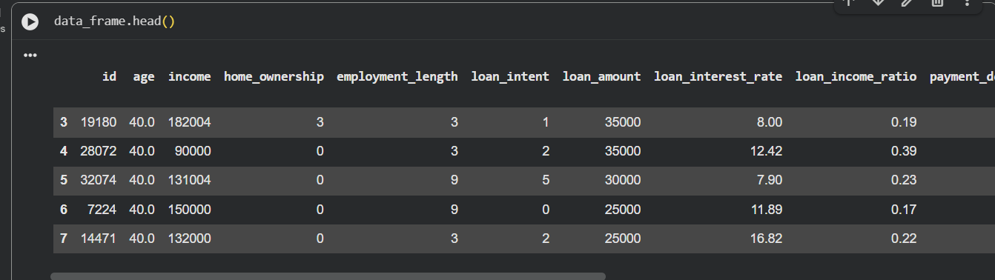

Here Label encoding was applied to convert categorical variables into numerical format

Task (4) – Classification Modelling of Clients Loan Approval Status
a) In your Final Python Notebook 2, you built THREE different models to predict loan approval status: Logistic Regression (LR), K Nearest Neighbour (KNN) and Naïve Bayes (NB). These algorithms are a mix of parametric and non-parametric algorithms.
1) Note down the type of each algorithm (parametric vs non-parametric),
2) name any learnable parameters, and
3) list any strategic hyperparameters for each algorithm which you want to consider tuning. Organise your answer in the table below:
[3 Marks]
Algorithm Name | Algorithm Type | Learnable Parameters | Some Strategic Hyperparameters
Naïve Bayes (NB) | Parametric | probabilities and likelihood probabilities (this learns the probability of a each kind of situation ) | var_smoothing(to prevent errors like zero probability and numerical errors)
Logistic Regression (LR) | Parametric | Uses weights and formulas and intercept | C (controls overfitting ), penalty (L1/L2), max_iter
K-Nearest Neighbour (KNN) | Non-parametric | No specific learnable parameters (this stores training data and compares all) | n_neighbors (K value), distance metric (e.g., Euclidean), weights

Task (4) – Classification Modelling of Clients Loan Approval Status
b) With the aid of your Final Python Notebook 2, use the training–test split approach with your retained applicable input features only and the target output feature to build your predictive classification models.
[3 Marks]
i. Screenshot
1) the list of all feature names used for building your classification models and the corresponding
2) data shape function output. (Paste screenshots of the relevant code output only; do not paste the Python code).

i. Screenshot

1)
Screenshot 1:

Feature names:

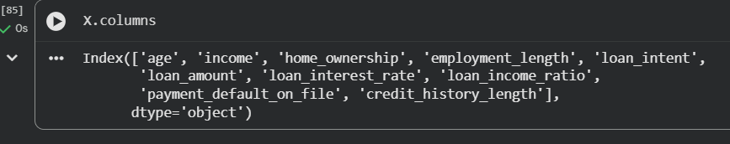

2) Screenshot 2:

Shape:

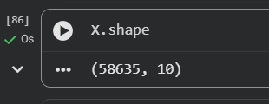

ii. In less than 150 words, research and justify (defend) your choice of the training-test split ratio and provide an in-text citation.

Here training test split in the ratio of 80 : 20 was selected .This means that 80 % percent of the data was used to training the model and 20 % percent was used for testing .This split helped and provided a good balance between train the model and testing the models performance on unseen or else new data model hasn’t seen(test data). If we use little amount if training data wil lead the model to underfitting , and too little data as test data will lead to providing un reliable outputs or else false predictions .This ration of 80 20 is the most commonly used ratio across the industry because e this leads to ensure that train has sufficient data and validation also have sufficient data .
References
Kuhn, M. and Johnson, K. (2013). Applied Predictive Modeling. New York: Springer.

iii. Provide as evidence the code block line and code output from your Final Python Notebook 2 that ensures two conditions:
1) all your models were tested on the same test instances (clients) in your dataset;
2) the labels ratio of approval Status “Accept” to “Reject” is the same in the training and test subsets.
3) State the training-test split function parameters in your code line that are responsible for meeting both conditions.
4) In less than 150 words, research and justify (defend) your decision to implement both conditions in your Python Notebook 2 notebook with in-text citations where possible.

- Evidence(code lines and the output)

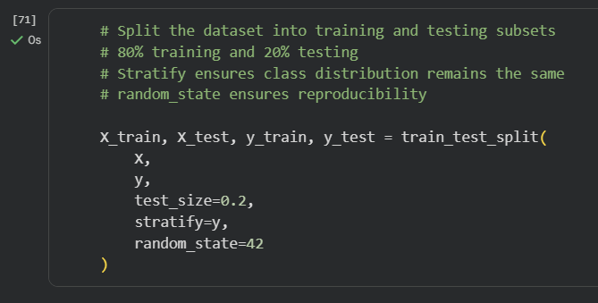

output screenshot

train data count

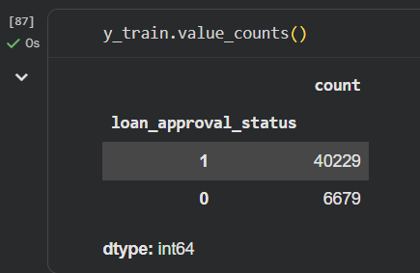

Test data count

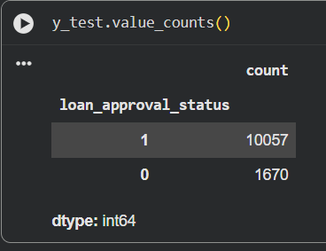

- Parameter states

The parameters used in the train test split are –
- test_size = 0.2

This is to ensure that 20% percent of the data is used for testing and 80 percent of the data is used for train the model

- random_state = 42

This to ensure that the same split happens every time and using the same data points like every time when the split happens same 80 percent goes for train the data and the same 20 percent goes for testing the data . This helps to ensure the reproducibility of the model .reproducibility means getting the same result again under same conditions.

- stratify = y

This controls the class distribution . Like this helps to keep the same class ratio in train and test sets .

References with in-text citation
Task (5) – Evaluating your Loan Approval Status Classification Models
Your finance team provided the following success criteria to guide you when evaluating and selecting your best model: “When evaluating your model's performance, which addresses your first research question (a). The model is expected to misclassify clients’ applications. Thus, the model should aim to predict as many “Reject” status for clients as many as possible to decrease the risk of future defaulted loan payments. However, the model should demonstrate that its high “Reject” prediction rate is mainly due to a larger number of correctly detected (predicted) rejected loan applications.”

a) With the aid of Final Python Notebook 2, for each of your models (Logistic Regression LR, Naive Bayes NB and K-Nearest Neighbours KNN)
1) paste the test confusion matrix,
2) the classification report and
3) the AUC-ROC curve graphs
as screenshots from the output of your Python code.
[3 Marks]

1) Screenshot of the test confusion matrix for (NB, LR, and KNN); make sure you title each matrix with its algorithm name

SECTION 1 — Logistic Regression

- Confusion Matrixs

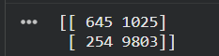

- Classification Report

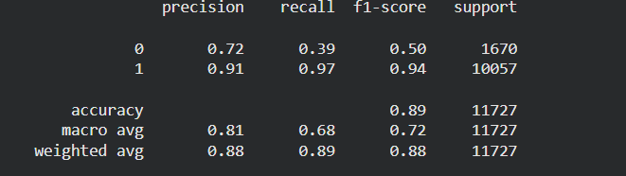

- ROC Curve

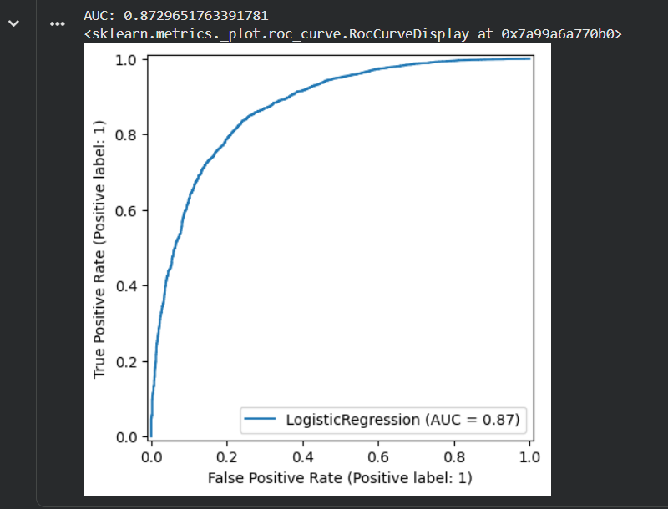

SECTION 2 — Naive Bayes

- Confusion Matrix

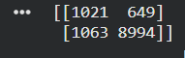

- Classification Report

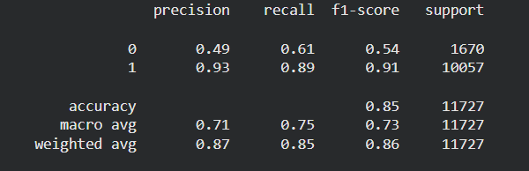

- ROC Curve

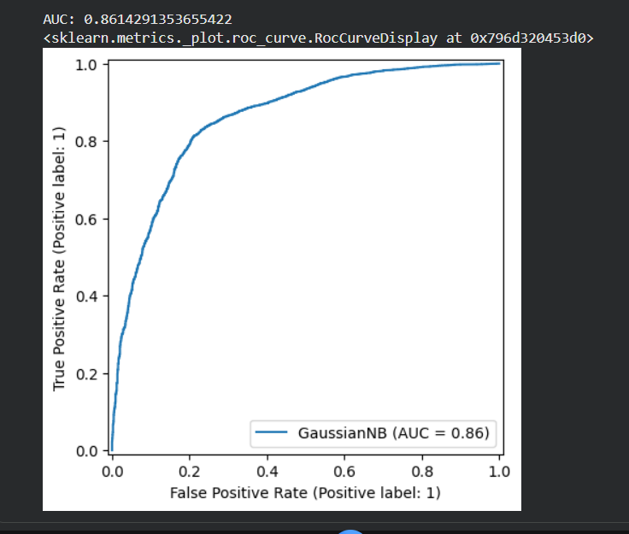

Section 3 - KNN

1. Confusion Matrix

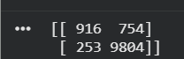

- Classification Report

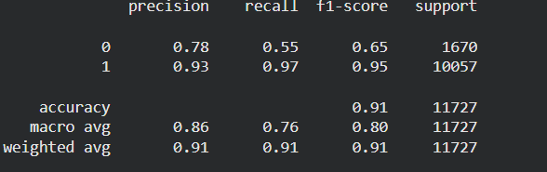

3. ROC Curve

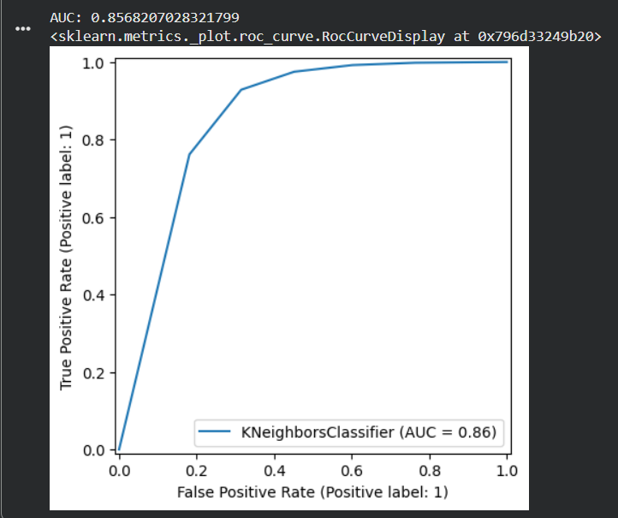

Task (5) – Evaluating your Loan Approval Status Classification Models
b) Five different classification evaluation metrics are calculated in your Final Python Notebook 2.
1) State which evaluation metric/metrics to “USE or “DO NOT USE” to closely interpret the above success criteria.
2) For justification, explain how closely your choice of “USE” or “DO NOT USE” for a metric interprets the given success criteria.
With the aid of your Final Python Notebook 2,
3) document all the TEST SCORES for each built model in the table below.
[7 Marks]
Metric | 1) USE or DO NOT USE | 2) Justification for choosing “USING” or “NOT USING” this metric in relation to the success criteria | Model | 3) Metric Test Score
Accuracy | Do Not Use | Accuracy can be misleading in imbalanced datasets and does not reflect and shoe how well the model identifies rejected clients, which is the main requirement of the model . | NB | 0.85
 |  |  | LR | 0.89
 |  |  | KNN (k=5) | 0.91
Recall | Use | Here Recall measures the ability of the model to correctly identify the true positives or else the rejected loan applications, which directly aligns with the requirement because we need to minimise risky approvals. | NB | class0 (recall = 0.39)  class1 (recall = 0.97)
 |  |  | LR | Class0=0.39  Class1=0.97
 |  |  | KNN (k=5) | Class0=0.55  Class1=0.97
Precision | Use | Precisionis to ensures that when the model predicts a client as rejected, it is correct, reducing unnecessary rejection of valid applicants. | NB | Class0=0.49  Class1=0.93
 |  |  | LR | Class0=0.72  Class1=0.91
 |  |  | KNN (k=5) | Class0=0.78  Class1=0.93
F1-score | Use | F1-scoreis combination of both precision and recall this balances both precision and recall, making it useful for evaluating performance when both false positives and false negatives matter In the scenario. | NB | Class0=0.54  Class1=0.91
 |  |  | LR | Class0=0.50  Class1=0.94
 |  |  | KNN (k=5) | Class0=0.65  Class1=0.95
AUC-Roc | Use | AUC-ROC gives a overall value od measures this shows model’s ability to distinguish between approved and rejected clients across all thresholds, providing an overall evaluation of classification performance. | NB | 0.86
 |  |  | LR | 0.87
 |  |  | KNN (k=5) | 0.86

Task (5) – Evaluating your Loan Approval Status Classification Models
c) Suggest a single best approval status classification model based on the ‘USED’ performance metrics scores you identified in Task (5-b). In less than 100 words, briefly describe how well your best model satisfies the needs of your finance team.
[2 Marks]
After analysing all the 3 classification models, the KNN model was selected as the best model based on the evaluation metrics, particularly regarding both recall and F1-score. Here The KNN model achieved the highest score of recall for the rejected class (which is class 0), which is the most critical requirement required here , because this is the fact that ensures that risky loan applicants are correctly identified.

Additionally, the KNN model achieved the highest F1 score for class 0, this indicating a good balance between precision and recall. So overall ,the KNN model best satisfies the finance team’s objective and purposes of minimising financial risk and improving decision-making reliability.

Task (5) – Evaluating your Loan Approval Status Classification Models
d) To enhance your selected best model/s performance (from Task 5-c), tune some of its possible hyperparameters, which you indicated in Task (4-a) for that specific algorithm. With the aid of Final Python Notebook 2, Re-train and test the best algorithm again with GridSearchCV
[5 Marks]
i. With the aid of your Final Python Notebook 2,
1) Paste into this report the line of code which shows evidence of specifying a parameters grid and applying the GridSearchCV function to rebuild your selected best model.
2) Then, document the estimated best hyperparameters for the optimised model.

- Evidence of GridSearchCV Code

The following below code was used in the Python Notebook 2 to define the parameter grid and apply GridSearchCV for tuning the K-Nearest Neighbour (KNN) model:

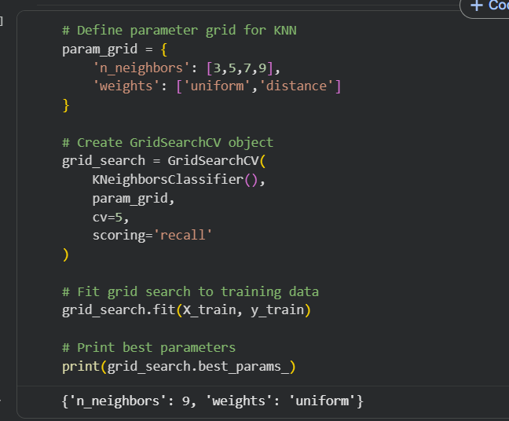

- Best Hyperparameters Identified

The optimal hyperparameter values obtained from GridSearchCV are:

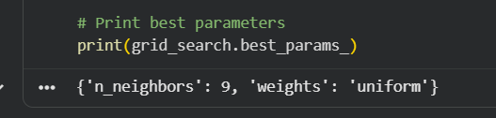

ii. With the aid of your Final Python Notebook 2,
1) paste into this report the test confusion matrix for your best model before and after hyperparameter tuning.
2) Also, document the new score/s of the “USED” performance metric/s of your choice to interpret the success criteria indicated in Task (5.b) before and after tuning.
3) Comment on whether the tuning of hyperparameters of your best model improved its positive predictive ability in line with the success criteria.

- BEFORE TUNING — CONFUSION MATRIX

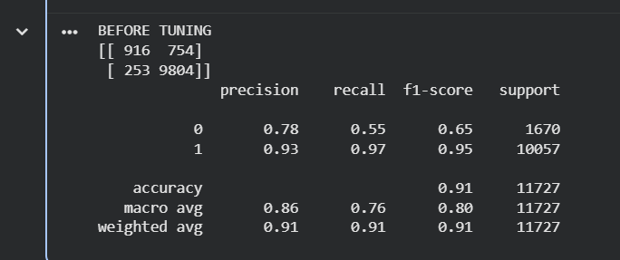

The above picture shows the confusion matrix of the K-Nearest Neighbour (KNN) model before hyperparameter tuning.

- AFTER TUNING — CONFUSION MATRIX

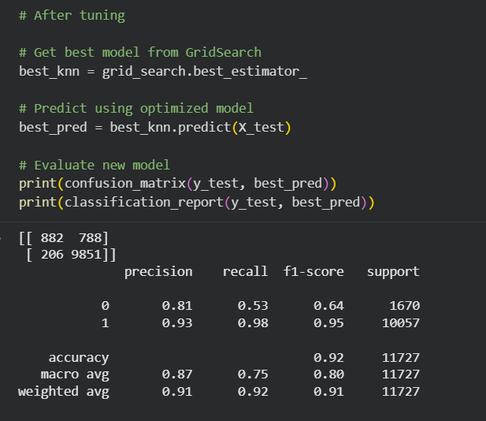

The above picture the confusion matrix of the KNN model after hyperparameter tuning using the GridSearchCV.

Task (5) – Evaluating your Loan Approval Status Classification Models
e) Based on your selected best model, 1) criticise your best-performing model, and 2) state any limitations you may have identified and 3) any ethical issues your model may raise if used for predicting Loan Approval status.
[2 Marks]
The final chosen model proves to be quite efficient after being tested on test set , in terms of the accuracy with which it predicts the approval status of applications, sometimes it can have certain drawbacks. It might happen that there will be cases when this machine learning algorithm misclassifies loan applicants. Also , its performance relies on the quality of the data used for training the model and its relevance.

In regard to the ethics aspect, the final chosen model might show certain biases due to features that are unequally represented within the data used for training the algorithm, for instance, gender or income level can raise ethical concerns or issues .

Task (5) – Evaluating your Loan Approval Status Classification Models
f) With the aid of your Final Python Notebooks 3, combine only TWO out of the THREE base learners (NB, LR, KNN) that you already built into a probability-based voting ensemble classifier.
[5 Marks]
i. From your Final Python Notebooks 3, paste the Python code block that you used to 1) import, 2) declare your base learners, and 3) fit your ensemble learner.
Task (5f)(i)

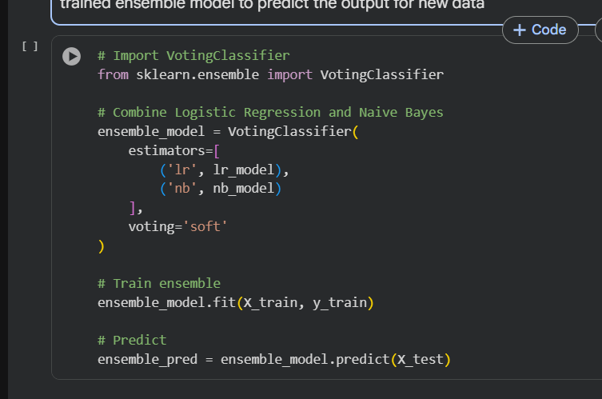

ii. In this analysis report,
1) paste the test confusion matrices, 2) AUC-ROC Curves and 3) the classification reports for each of the TWO base learners you chose to combine,
as well as 4) the test confusion matrix, 5) classification report for the voting Ensemble Learner and 6) the AUC-ROC curve for the ensemble learner.
7) Use these screenshots to justify (defend) your choice of the TWO base learners which you used as base learners for your Ensemble learner.

1) Paste the test confusion matrices for each base learner (2 x matrices )

LR confusion matrix

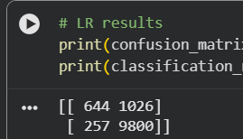

NB confusion matrix

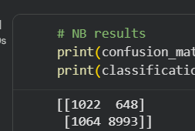

2) Paste the AUC-ROC for each Base learner (2 x AUC-ROC graphs)

LR ROC curve

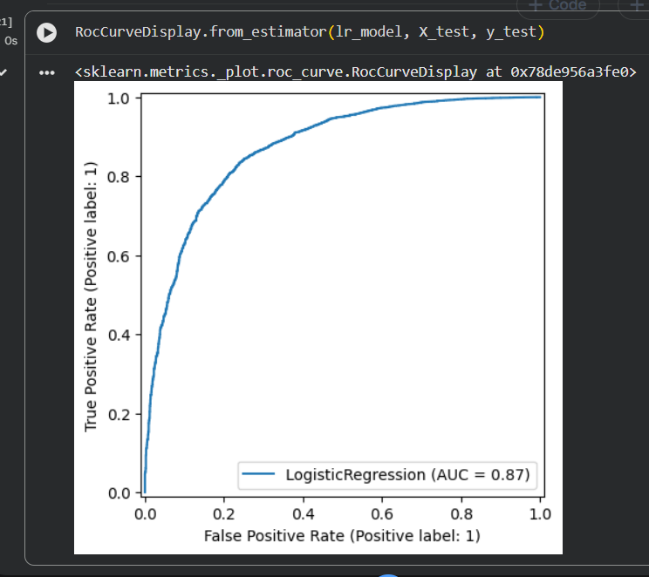

NB ROC curve

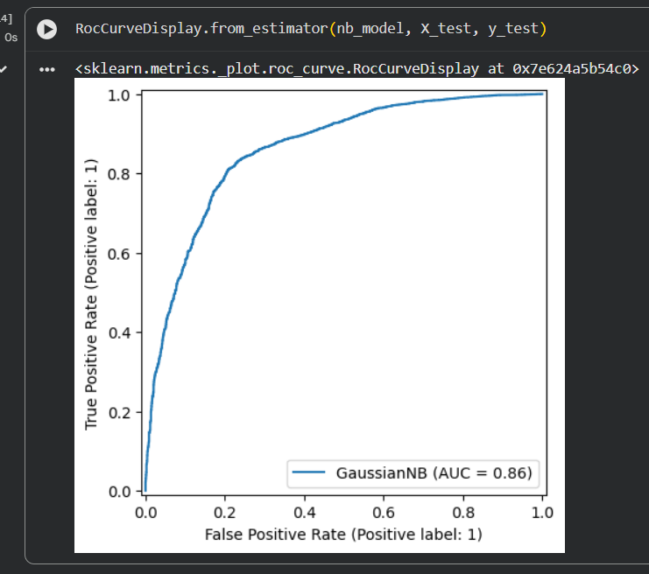

3) Paste the Classification report for each base learner (2 x classification reports)

LR classification report

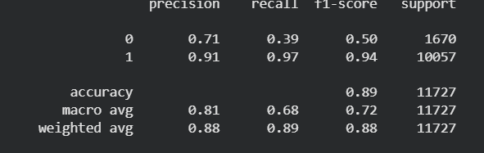

NB classification report

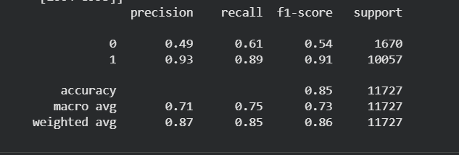

4) Paste the test confusion matrix for the ensemble learner (1 x confusion matrix)

Ensemble confusion matrix

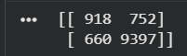

5) Paste the AUC-ROC for the ensemble learner (optional) (1 x AUC-ROC graph)

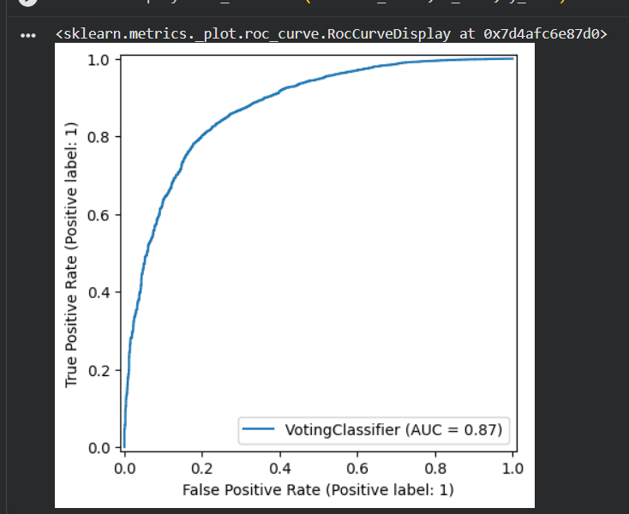

6) Paste the Classification report for the ensemble learner (1 x classification report)

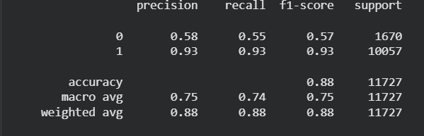

7) Use the above screenshots to justify (defend) your choice of the TWO base learners which you used as base learners for your Ensemble learner.

Logistic regression and naïve bayes models were selected as the base algorithms for the ensemble learning because of their complimentary nature. Logistic regression is good in handling linear associations between features and response and naïve bayes uses simple assumptions to create a probabilistic model and still performs well in random inputs .

According to the performance metrics like , both classifiers performed reasonably well in predicting recall and precision, especially when dealing with rejected cases. Their ROC curves show that discrimination of the models is quite good.

By applying the soft voting on the two classifiers, the prediction accuracy became better and accurate since the weaknesses in both models are eliminated to a certain extent . In this case, the predictions are relatively reliable in predicting high-risk applicants that need to be rejected to minimize risks according to financial experts' objective.

iii. Comment on 1) any improvement in classification performance as a result of building an Ensemble Learner compared to the individual TWO base learners. 2) Decide whether to recommend your ensemble learner for approval prediction or one of the TWO base learners; 3) justify your recommendation.

Regarding the classification accuracy, the combined model made up of the Logistic Regression model and the Naïve Bayes model depicts significant improvement compared to the two base models separately. The combination of the models using soft voting helps mitigate the problem of misclassification through balancing.

Also , the difference in the performance metrics between the two models is not significant, and there might even be cases where one of the two models performs equally well if not better than the other, especially when considering recall.

Thus, it would be reasonable to use the combined model in predicting loans as it would be relatively more reliable and robust compared to the two base models.

Case Study Title
Case Study (B): Predicting Maximum Loan Amount.
Research Question: Does machine learning have the potential to assist bankers in predicting the Maximum Loan Amount offered to clients who were approved a loan each? [Total 36 Marks]

Task (1) – Domain Understanding and Designing Your Regression Experiments
The bankers decided that regression modelling is required to predict Maximum Loan Amount for those who are approved a loan. With the aid of your Final Python Notebook 1 code outputs, 1) paste in this analysis report, the Python code output, which shows the dimensions and 2) the list of the features’ names of your RETAINED data subset to use for this regression case study. [2 Marks]

Task (1) – Domain Understanding and Regression experiments

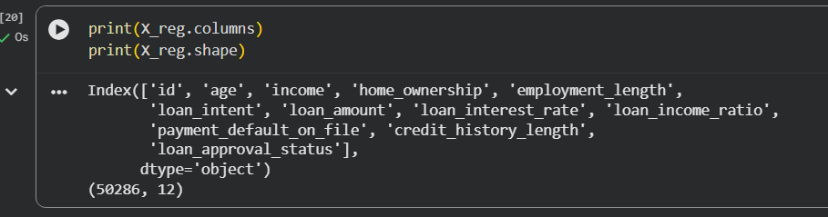

Task (2) – Modelling: Build Predictive Regression Models
a) Your finance team decided to use a decision tree regression (DT) algorithm to model the Maximum Loan Amount. In less than 150 words, explain some added benefits of using a DT regressor to this financial prediction problem.
[2 Marks]
The Decision Tree regression technique is used most of the time for the financial prediction scenarios under study due to its ability to capture non linear relations among variables like income level, amount of loan, and the credit score of customers. It is also possible to use this algorithm without feature scaling and for handling numeric and categorical variables. Decision trees have high interpretability and allow explaining how the predictions are made , which is very much useful when applying machine learning models in decision making processes. Moreover, interactions among variables that might affect the loan limit could be captured by the model. Considering this model overfitting could be a potential problem for decision trees; thus, pruning is necessary (Kuhn & Johnson, 2013).
References with in-text citation
Kuhn, M. and Johnson, K. (2013). Applied Predictive Modeling. New York: Springer.

Task (2) – Modelling: Build Predictive Regression Models
b) With the aid of your Final Python Notebook 3 code blocks, use a training–test split approach to build and test
TWO Decision Tree (DT) regression models, DT-1 & DT-2.
[6 Marks]
i. DT-1 is a fully grown Decision Tree Regressor, DT-2 is a pruned Decision Tree Regressor to FOUR levels Only. 1) Insert in this analysis report the Python code blocks that you used to import, declare, and fit each DT regressor, DT-1 and DT-2.
Decision Tree Regressor (DT-1)

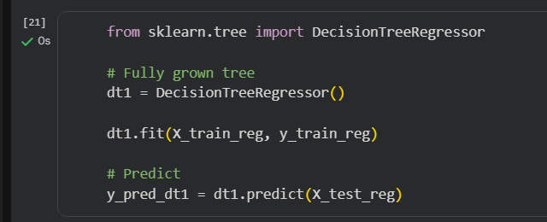

Decision Tree Regressor (DT-2)

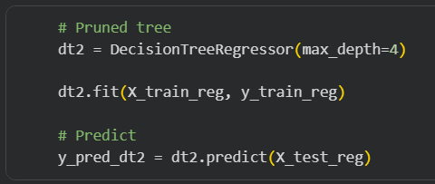

ii. Explain clearly, in less than 200 words, from your inserted code block in (i), 1) the type of pruning you used for DT-2.
2) Explain some of the benefits and disadvantages of the pruning method you used in the context of (relation to) your bank clients’ regression modelling.
The type of pruning used in DT-2 is called pre pruning also known as early stopping. It consists in setting the depth of the decision tree, which is limited with the use of max_depth=4 parameter.

First, it should be noted that one of the advantages of pre pruning is that it does help to reduce overfitting because it creates a simplified model that will have higher generalisation performance. So, in the field of financial applications, it will ensure greater stability in predicting maximum loan amounts. Also , the simpler model will be easier to understanded by the financial experts.
Finally one of the disadvantages of pre pruning is that it leads to underfitting. In other words, the model will not consider all the possible relations in data, so some predictions related to specific customers can become less accurate.

Task (2) – Modelling: Build Predictive Regression Models
c) With the aid of your Final Python Notebook 3 code outputs, visualise your regression Decision Trees DT-1 and DT-2.
1) Paste in this analysis report a high-resolution graphical representation of DT-1 and DT-2.
[4 Marks]

Decision Tree Visualisations

DT-1 (Fully Grown Tree)

2. DT-2 (Pruned Tree)

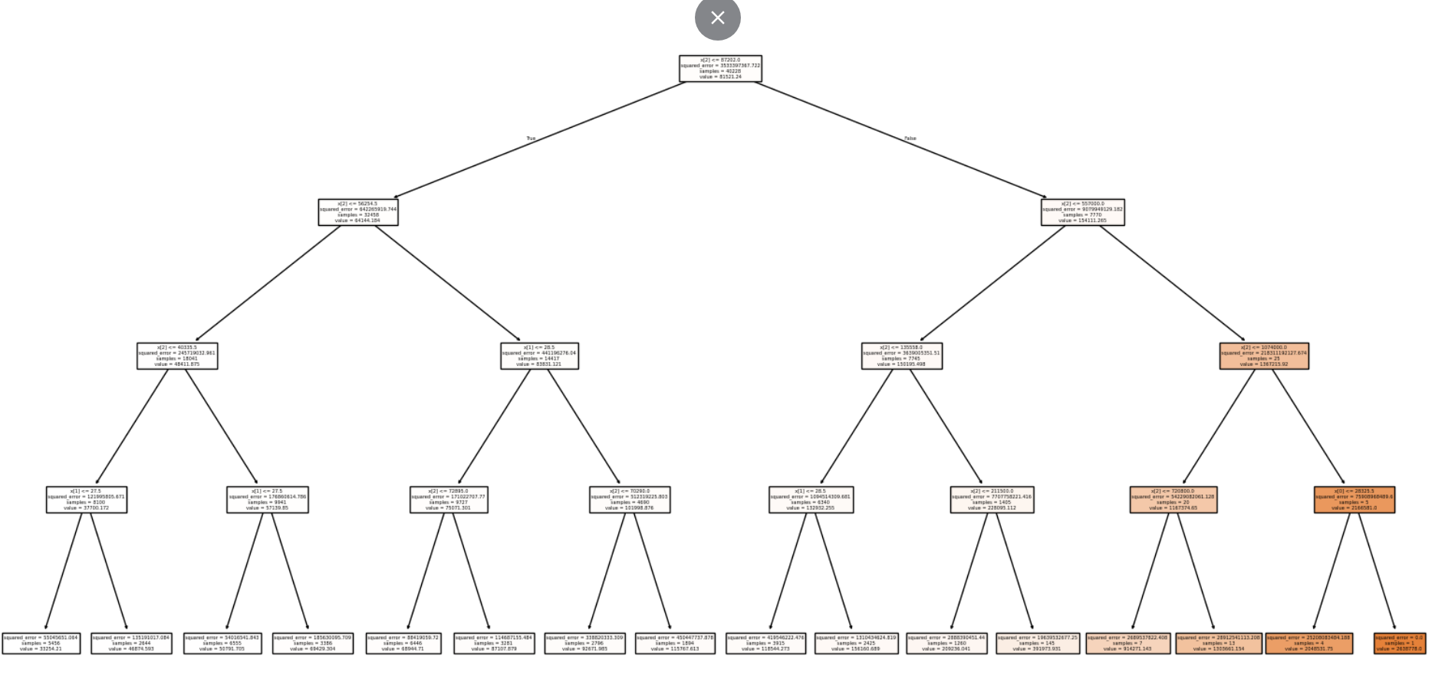

Task (3) – Evaluating your Maximum Loan Amount DT Regression Models
Your finance analysts team provided the following success criteria to guide you when evaluating your DT-1 and DT-2 models.
“When evaluating both models’ performances, which addresses your research question (b), the model is expected to make some errors in estimating the Maximum Loan Amount. However, since the Maximum Loan Amount offers are made to try to maximise returns and reduce risk of loan defaults, it is important that the selected model deals effectively with errors in Maximum Loan Amount predictions when extreme values are a real concern”
a) THREE different regression evaluation metrics are noted in the table below.
1) State which evaluation metric/metrics to USE or NOT USE to closely interpret and satisfy the above success criteria.
2) Justify (Defend) your choice of USE or DO NOT USE for each metric.
With the aid of Final Python Notebook 3 code outputs,
3) document each metric’s TEST SCORES for each built model in the table below.
[8 Marks]
Metric | 1) USE or DO NOT USE | 2) Justification for choosing “USING” or “NOT USING” this metric in relation to the success criteria | Model | 3) Metric Test Score
MSE | USE | Mean squared error stops larger errors more heavily, making it suitable for this problem where extreme prediction errors must be minimised to reduce financial risk . | DT-1 (Fully Drown) | 72136112.60
 |  |  | DT-2 (Pruned) | 379554693.77
MAE | USE | Mean absolute error provides a clear measure of average prediction error, making it useful for understanding how far predictions deviate from actual values in practical terms. | DT-1 (Fully Drown) | 1270.92
 |  |  | DT-2 (Pruned) | 11327.63
R-Square | DO NOT USE | R² measures overall fit but this does not directly account for the level of prediction errors, especially when considering extreme values, which are critical in this financial context. | DT-1 (Fully Drown) | 0.9738
 |  |  | DT-2 (Pruned) | 0.8623

Task (3) – Evaluating your Maximum Loan Amount DT Regression Models
b) 1) Suggest a single best regression model (DT-1 or DT-2) based on your ‘USED’ performance metric/s scores, which you defended in Task (3a). 2) Explain how your suggested model fulfils the success criteria.
[4 Marks]
From the selected metrics for evaluating models, it can be concluded that DT-1 is the best among the other regression models. This conclusion decision is based on the fact that DT-1 has much more small error values compared to DT-2 .. So Overall DT-1 is considered a better predictor of the maximum amount of the loan.
The selected model meets all the criteria of success because it manages to control prediction errors successfully. In other words the DT-1 model is capable of handling outliers. The low mse value shows that high errors do not occur. At the same time, the low Mae value proves the consistency of the predictions.

Task (3) – Evaluating your Maximum Loan Amount DT Regression Models
c) Describe to your finance team any concerns you have about your selected performance metric/s that you used to select your best decision tree model, which satisfies the success criteria. [200 words maximum] with in-text citation.
[4 Marks]
The chosen criteria for performance the MAE and MSE, are suitable for analysing the accuracy of prediction, but there are some drawbacks with them. First, the MSE gives too much weight to large errors because of squaring the residuals this may result in the model being more concerned about outliers than the accuracy of prediction as a whole. And MAE equally weighs each error without singling out extremely bad predictions in finance, which would cost in a massive scale if they were made.

Second, these measures are scale dependent or else this means that the results will vary depending on the scale of the target feature. Third MAE and MSE cannot distinguish whether there is an overprediction or underprediction, which is critical information in credit applications. In Final the use of MAE and MSE is beneficial for model evaluation, but they require careful consideration and interpretation in conjunction with domain knowledge (Kuhn and Johnson, 2013).
References with in-text citation
Kuhn, M. and Johnson, K. (2013). Applied Predictive Modeling. New York: Springer.

Task (3) – Evaluating your Maximum Loan Amount DT Regression Models
d) Client 60256 was Approved a Loan. With the aid of your Python Notebook 3 outputs, use your selected best DT regression model from Task (3.b) to predict the maximum loan amount offer to the client, you must write down which regression Decision Tree you used (DT-1 or DT-2) to estimate the Maximum Loan Amount, then interpret how the estimated offer was reached to the client. Client 60256 attributes’ values are in the following table: [6 Marks]
Variable Name Value  ID 60256  Sex Female  Age 56 Years old  Education Qualifications Unknown  Income 57,000  Home Ownership Rent  Employment Length 15  Loan Intent Medical  Loan Amount 25700  Loan Interest Rate 23%  Loan-to-Income Ratio (LTI) 10%  Payment Default on File No  Credit History Length 35  Loan Approval Status Approved  Maximum Loan Amount £83,196  Credit Application Acceptance 0 | Decision Tree Regressor (DT-1) model was applied in order to predict the maximum loan for customer 60256. The forecasted maximum loan amount was calculated to be £83,196.  This calculation was done on the basis of different characteristics associated with the particular client, such as an annual income of £57,000, employment of 15 years, loan purpose as a medical loan, and credit history for 35 years.  DT-1 model was chosen since it has the minimum error value (MSE and MAE) which means better results as compared to the pruned decision tree (DT-2).

